Practical 6
About Hive:
Apache Hive is a distributed, fault-tolerant data warehouse system that enables analytics at a massive scale. Hive Metastore(HMS) provides a central repository of metadata that can easily be analyzed to make informed, data driven decisions, and therefore it is a critical component of many data lake architectures. Hive is built on top of Apache Hadoop and supports storage on S3, adls, gs etc though hdfs. Hive allows users to read, write, and manage petabytes of data using SQL.

Starting Hive:
Type hive in the CLI in cloudera to start hive.
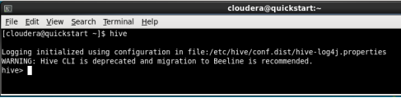

Creating Database in hive:
Syntax: CREATE DATABASE database_name;
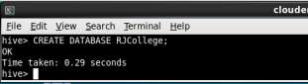

Checking all the databases:
Syntax: SHOW DATABASES;
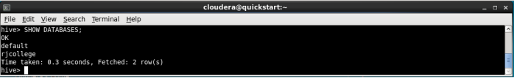
Setting a database for use:
Syntax: USE database_name;
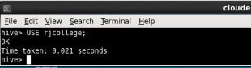
Creating a table in hive:
Syntax: CREATE TABLE table_name(column_name datatype) ROW FORMAT DELIMITED FIELDS TERMINATED BY ‘,’;
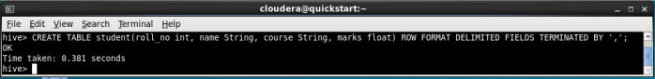

Adding data into the table from a text file:
Create a text file inside HDFS with CLI or file browser with entries in the same order as column names in the above table into the
Syntax: LOAD DATA ‘/hadoop/data/textfile_name’ INTO TABLE table_name;
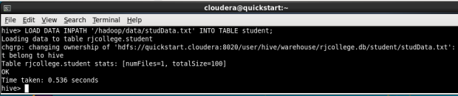

Displaying all records from the table
Syntax: Select * from table_name
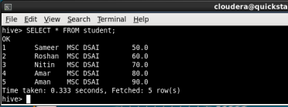

1. Create the csv file to store the data of the LIC Insurance policy customers and enter some data
Dsd
- gedit custDetails.csv

3272981,suman,04/29/2001,suman@gmail.com,3079875121,vikhroli,M
3272982,foram,04/30/2001,foram@gmail.com,3079876062,dombivali,F
3272983,savri,05/01/2001,savri@gmail.com,3079877003,mulund,F
3272984,siddhesh,05/02/2001,siddhesh@gmail.com,3079877944,ghatkopar,M
3272985,jayesh,05/03/2001,jayesh@gmail.com,3079878885,vikhroli,M
- gedit policySaleDetails.csv

18641,3272981,83475,04/29/2021,yearly,2584846
18642,3272983,83476,04/30/2021,quarterly,54545445
18643,3272984,83477,05/01/2021,monthly,774474
18644,3272985,83473,05/02/2021,weekly,7452558
18645,3272982,83474,05/03/2021,yearly,7474785
- gedit policyDetails.csv

83473,trade,Health,34,20,30%
83474,union,Motor,18,5,40%
83475,backwardhome,home,35,50,40%
83476,Lpg,fire,16,10,60%
83477,smallvillage,travel,5,1,40%

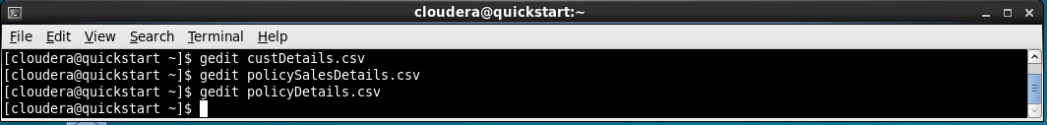

2. Create a data warehouse database named ‘LICDW’ using Hive
- CREATE DATABASE licdw;
3. Create an Internal/managed table for CustDetails using Hive
- USE licdw;
- CREATE TABLE customer (id int, name string, dob date, email string, contact string, address string, gender string) ROW FORMAT DELIMITED FIELDS TERMINATED BY ',';
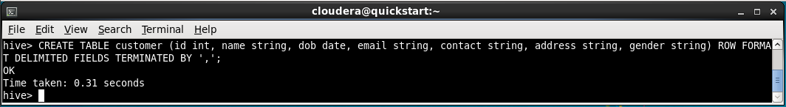

4. Load the data of custDetailsData.csv into the CustDetails table
- LOAD DATA LOCAL INPATH '/home/cloudera/custDetails.csv' INTO TABLE customer;
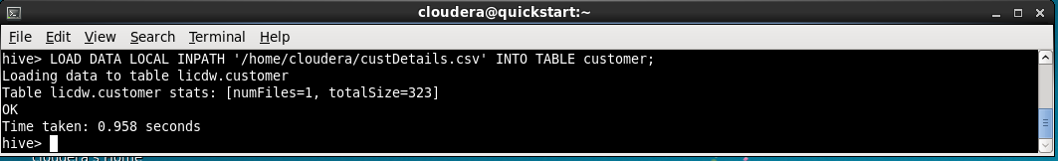

5. Display all records of custDetails table
- SELECT * FROM customer;
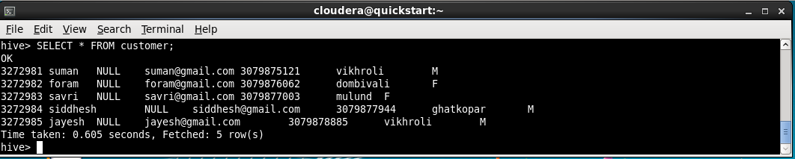

6. Create a policySaleDetails table as an external table using Hive
- CREATE EXTERNAL TABLE policy_detail(id int, name string, type string, age_criteria int, tenure int, maturity string) ROW FORMAT DELIMITED FIELDS TERMINATED BY ',' STORED AS TEXTFILE LOCATION '/home/cloudera/policy_detail_data';
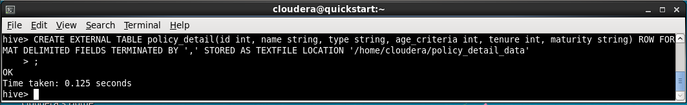
7. Load the data of PolicySaleDetailsData.csv file to PolicySaleDetails table
- LOAD DATA LOCAL INPATH '/home/cloudera/policySalesDetails.csv' INTO TABLE policy_detail;
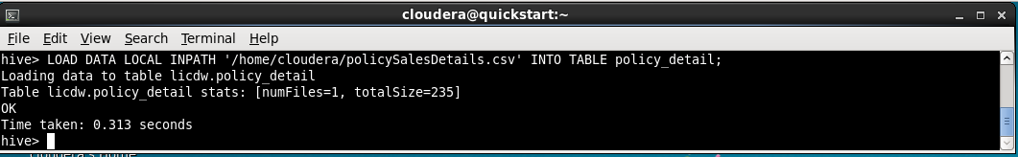
8. Display the schema and data details of the PolicySaleDetails table
- SELECT * FROM policy_detail;
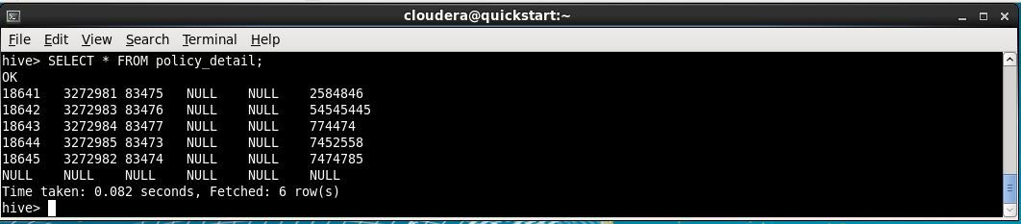
9. Skip header line of dataset file while loading data in Hive table
- ALTER TABLE policy_detail SET TBLPROPERTIES("skip.header.line.count"="1");
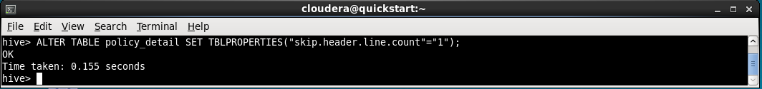
10. Insert some records in both internal and external Hive tables using the Insert command
- INSERT INTO customer VALUES(3272986, 'sameer', '12/09/1998', 'sam@gmail.com', 12456853233, 'Dombivli', 'M');
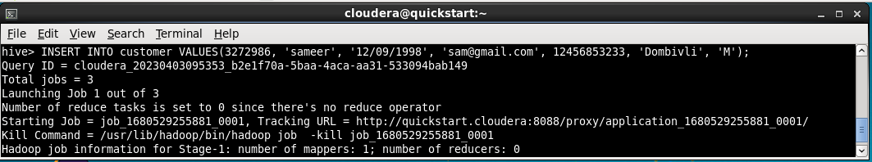
- INSERT INTO policy_detail VALUES(83478, 'smallvillage', 'travel', 5, 1, '40%');
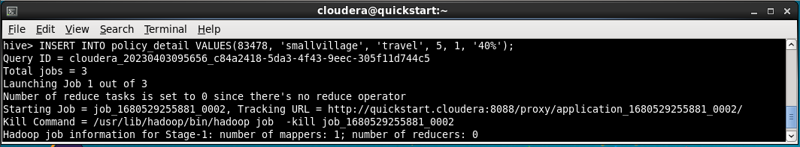
11. Create the PolicyDetails temporary table
- CREATE TEMPORARY TABLE policy_detail_temp(id int, name string, type string, age_criteria int, tenure int, maturity string
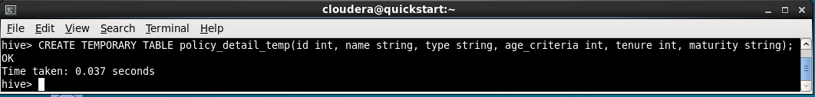

12. Insert 2 records in the PolicyDetails table using insert command
- INSERT INTO policy_detail_temp VALUES(32768, 'trade', 'health', 24, 30, '40%');
- INSERT INTO policy_detail_temp VALUES(32769, 'union', 'motor', 18, 5, '30%');
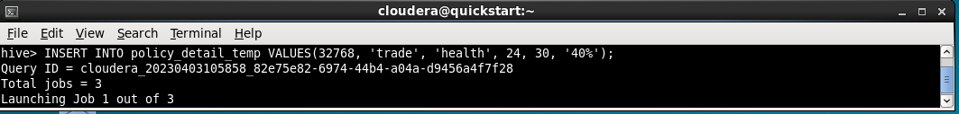

13. Check the existing hive version, if it is 4.x then try transaction table creation
We can check hive version using command
- ! hive --version
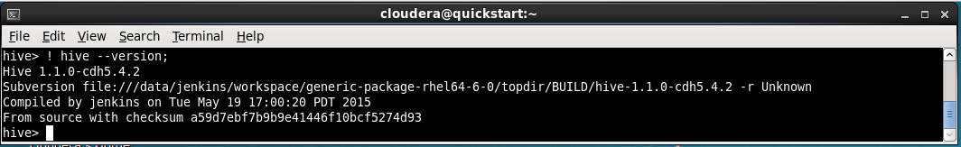

14. Create PolicyDetailsDup table using PolicyDetails table, using CTAS statement
- CREATE TABLE policy_details_dup AS SELECT * FROM policy_detail;
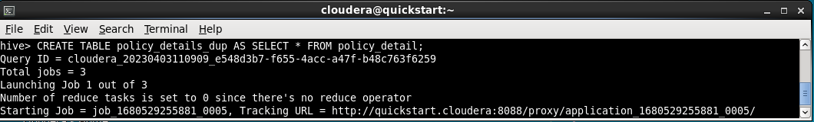

15. Execute describe and select statements for PolicyDetailsDup table
- DESCRIBE policy_details_dup;
- SELECT * FROM policy_details_dup;
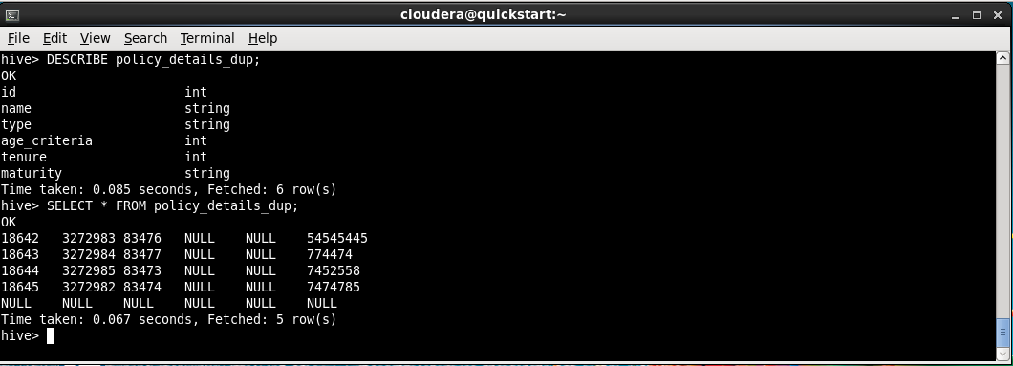

16. Create a PolicyDetailsLike table using the existing PolicyDetails table
- CREATE TABLE policy_details_like LIKE policy_detail;
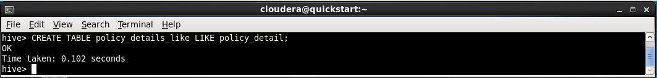

17. Execute describe and select statements for PolicyDetailsLike table
- DESCRIBE policy_details_like;
- SELECT * FROM policy_details_like;
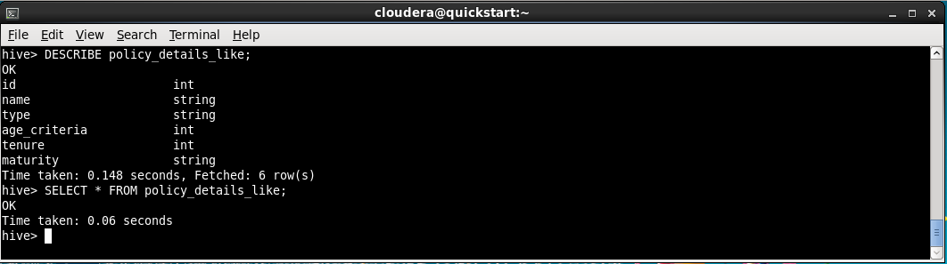

18. Display the list of customers and their mail ids from the custDetails table
- SELECT name, email FROM customer;
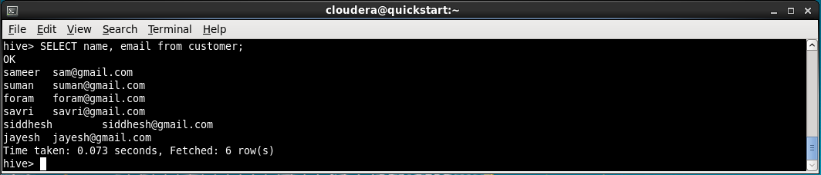
19. Get the count of the total number of customers
- SELECT COUNT(*) FROM customer;
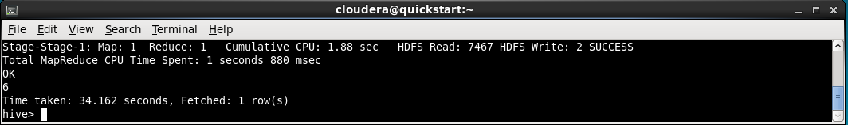
20. Display the premium paid details of customer having id 3272982
- SELECT * FROM policy_sales WHERE cust_id = 3272982;
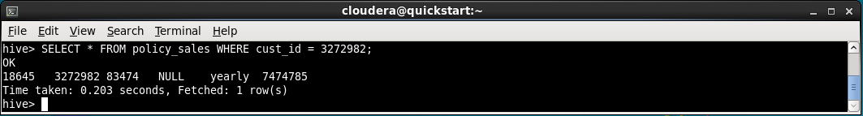
21. Display the policy with maximum benefit
- SELECT * FROM policy_detail ORDER BY maturity DESC LIMIT 1;
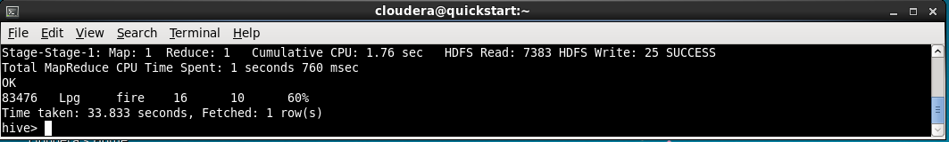
22. Display the details of policy having tuners in the range of 24 to 48 months
- SELECT * FROM policy_detail WHERE tenure BETWEEN 24 AND 48;
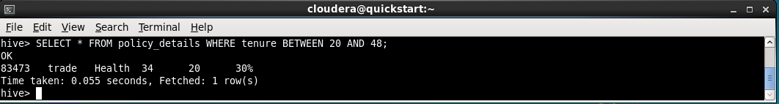

23. Get each customer's name, policy purchased and its type
- SELECT c.name, pd.name, pd.type FROM licdw.customer c INNER JOIN policy_sales ps ON ps.cust_id = c.id INNER JOIN policy_details pd ON pd.id = ps.policy_id;
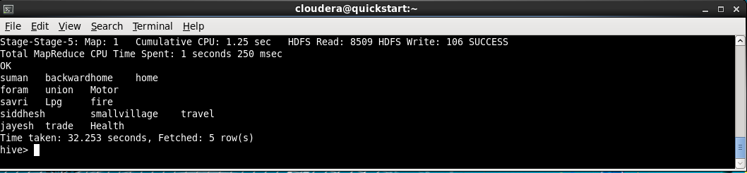

24. Display all policy types using distinct clause
- SELECT DISTINCT type FROM policy_details;
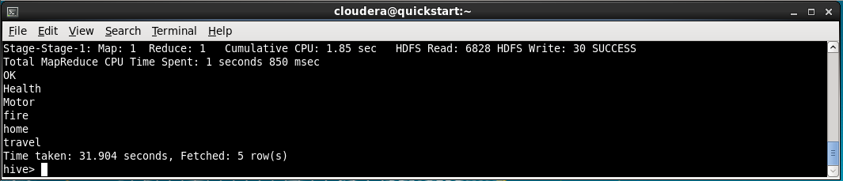

Partitioning Hive Tables
1. Create and use a database named ad ‘college’
- CREATE DATABASE college;
- USE college;
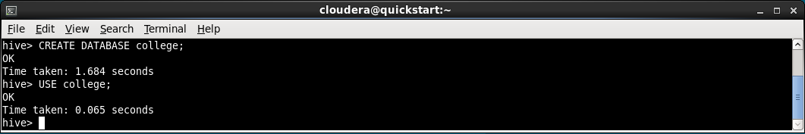
2. Create the partitioned table named ‘student’ to store the students information that is partitioned by the class values
- CREATE TABLE student(roll_no INT, name STRING, program STRING, total_marks INT, grade STRING, sgpa FLOAT, cgpa FLOAT) PARTITIONED BY (class STRING) ROW FORMAT DELIMITED FIELDS TERMINATED BY ',';
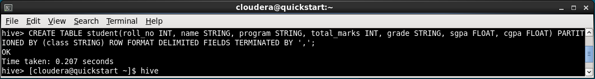
3. Create a csv file for student information and load it in the Hive table
- gedit studinfo.csv
1,Amit,MSc DSAI,560,A,6.7,6.0,Part1
2,Sam,MSc DSAI,600,B,5.5,3.0,Part1
3,ABC,MSc DSAI,700,F,1.0,2.0,Part1
4.XYZ,MSc DSAI,400,C,4.0,5.0,Part1
5,QWE,MSC DSAI,600,D,3.9,2.5,Part1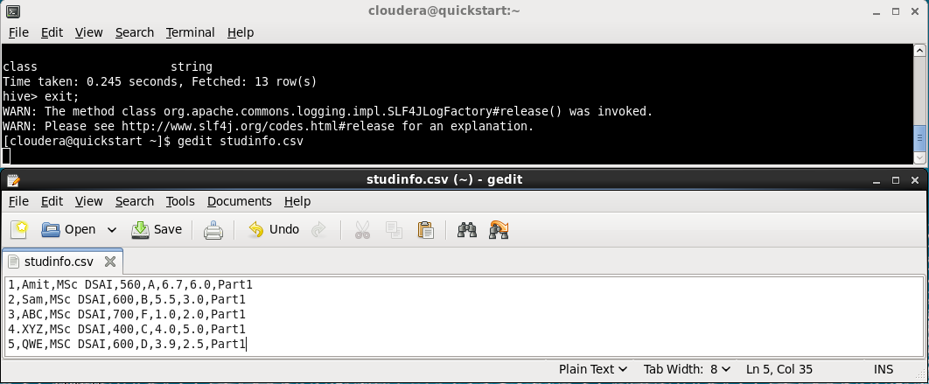
- CREATE TABLE stud_temp(roll_no INT, name STRING, program STRING, total_marks INT, grade STRING, sgpa FLOAT, cgpa FLOAT, class STRING);
- LOAD DATA LOCAL INPATH '/home/cloudera/studinfo.csv' INTO TABLE stud_temp;
- SET hive.exec.dynamic.partition=true; SET hive.exec.dynamic.partition.mode=nonstrict;
- INSERT OVERWRITE TABLE student PARTITION(class) SELECT * FROM stud_temp;
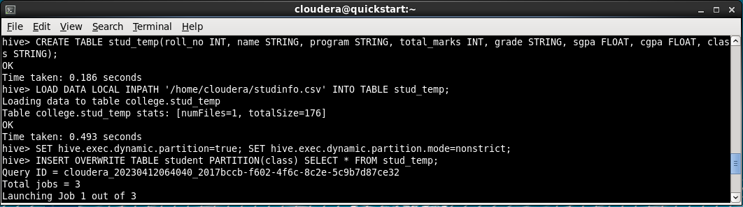
4. Display the schema with and without Formatted option
- DESCRIBE FORMATTED student;

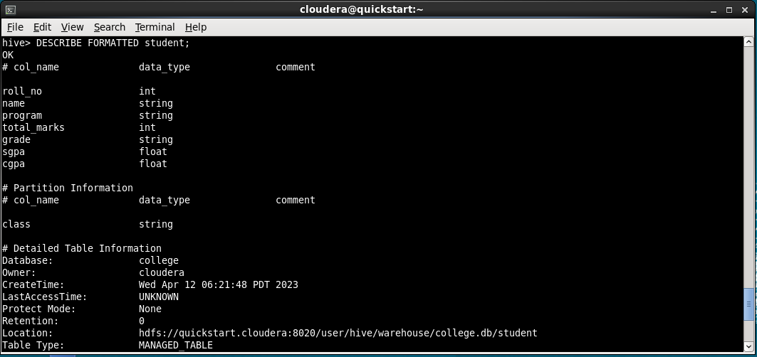
- DESCRIBE student;
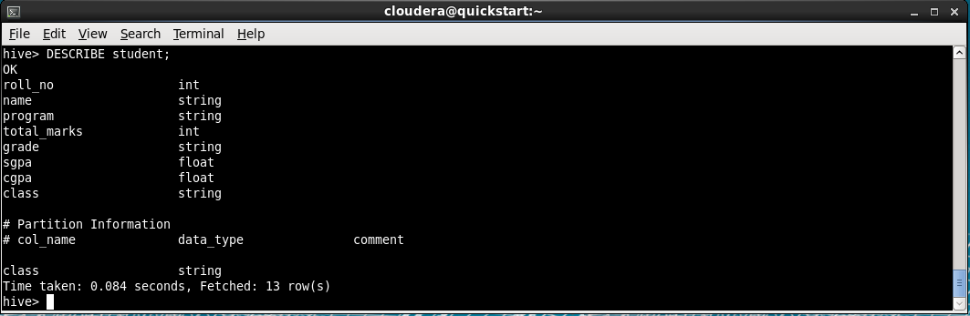
5. Display all partitions of the student table
- SHOW PARTITIONS student;
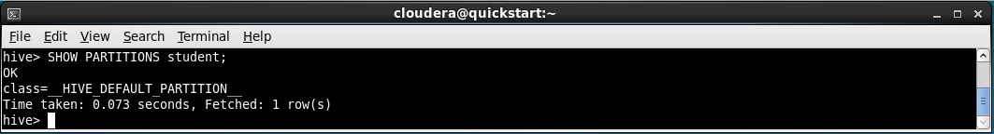
6. Create a partitioned table named ‘StudProg’ that is partitioned by the program and class
- CREATE TABLE stud_prog(roll_no INT, name STRING) PARTITIONED BY (program STRING, class STRING) ROW FORMAT DELIMITED FIELDS TERMINATED BY ',';
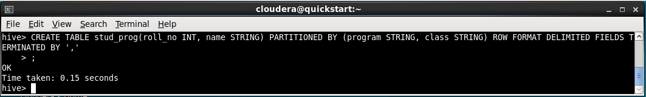
7. Display all partitions of the StudProg table
- DESCRIBE stud_prog;
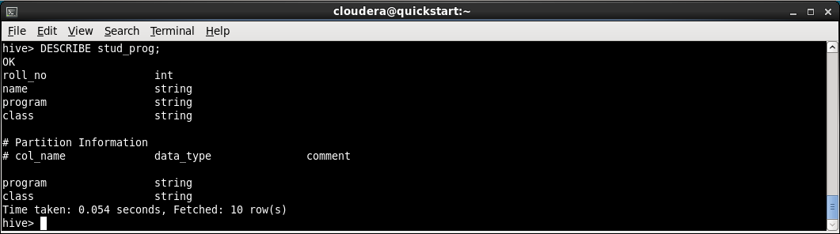
8. Display all partitions of the StudProg table from HDFS
- hdfs dfs -ls ‘/user/hive/warehouse/college.db/student’
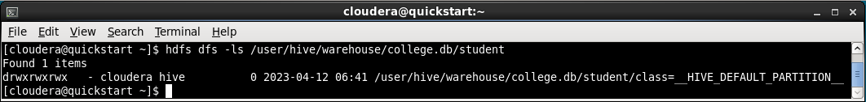
9. Insert data in partitioned hive table ‘student’ using insert statement
- INSERT INTO student PARTITION(class='Part1') VALUES(6,'asdf','MSC DSAI',350,0.6,2.5,'Part1');
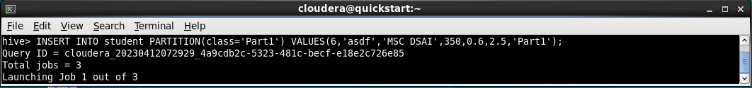
10. Display all records of the hive table named student
Hive Queries

1. Create and use a database named ‘jdk’.
- CREATE DATABASE jdk;
- USE jdk;
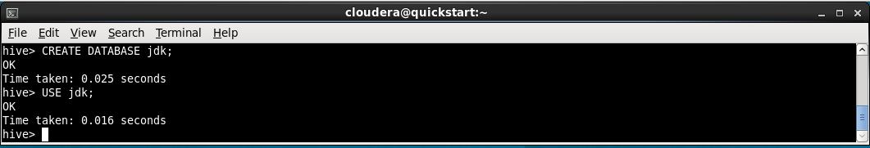

2. Create a table named ‘people’ with the following attributes.
Attributes:
Name, mobileNumber, dob,salary
- CREATE TABLE people(name STRING, m_no STRING, dob DATE, salary INT) ROW FORMAT DELIMITED FIELDS TERMINATED BY ',';
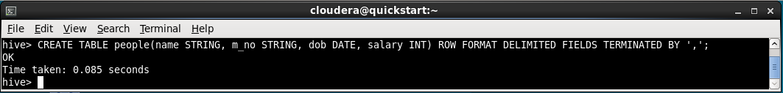

3. Create a csv file and save the data.
- gedit peoples.csv
Ashish,7686546789,1999-05-15,54321
Ashu,8767876545,1994-07-29,34567
Devansh,7685976543,1890-08-20,65432
Divya,8767567845,1990-09-24,12345
Ant,9876785678,1997-10-22,54325
Hardik,9878907657,1988-11-23,54345
Ant,9876543219,1989-12-12,11245
Antsha,8976532456,1789-03-13,23456
Hardik,8765467453,1987-04-13,43567
Hardik,8765431234,1995-06-19,43215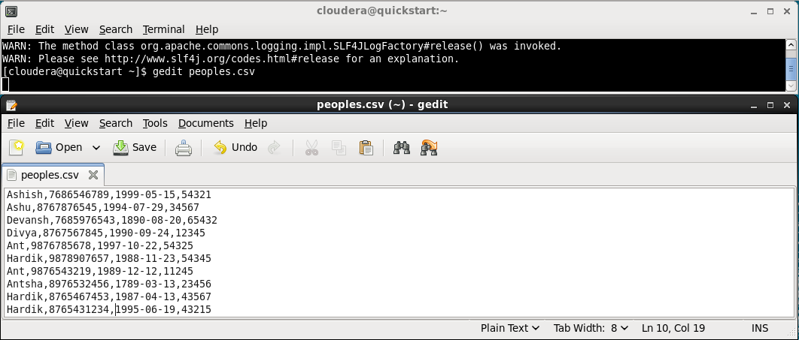
4. Copy the above csv file in the hdfs directory named ‘hdfspeople’.
- hdfs dfs -mkdir hdfspeople
- hdfs dfs -put '/home/cloudera/peoples.csv' hdfspeople
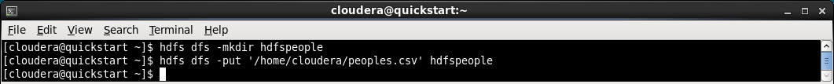
5. Load data in hive table ‘people’ .
- LOAD DATA INPATH 'hdfspeople/peoples.csv' INTO TABLE people;
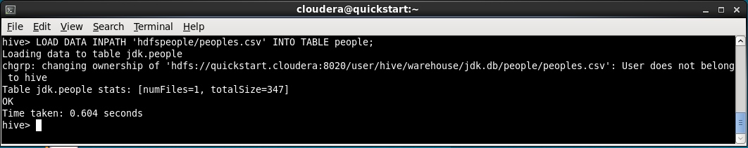

6. Display all records of the ‘people’ table.
- SELECT * FROM people;
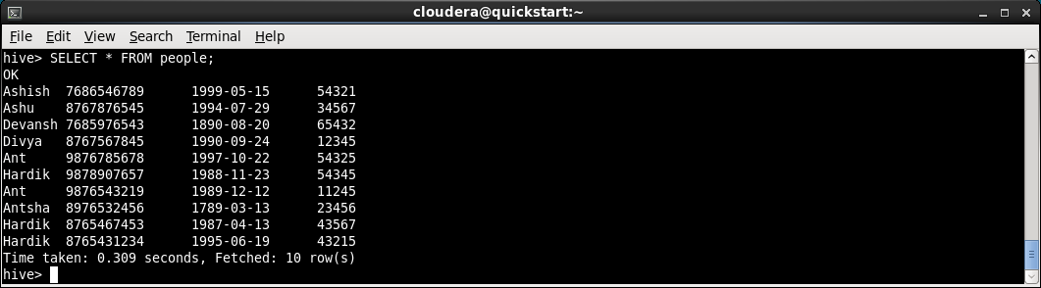

7. Display name and dob from ‘people’ table.
- SELECT name, dob FROM people;
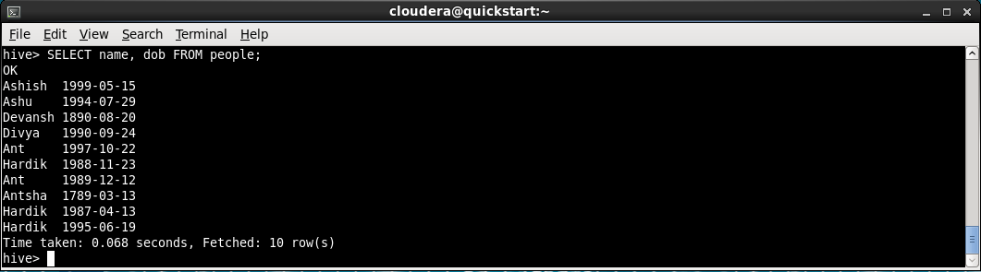

8. Display name and salary from ‘people’ table in an ascending order of name column .
- SELECT name, salary FROM people ORDER BY name ASC;
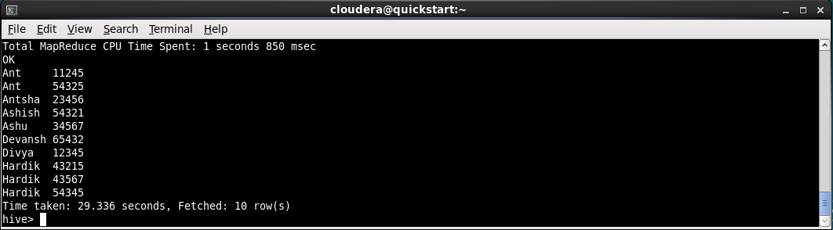

9. Display name and salary from ‘people’ table in descending order of salary column.
- SELECT name, salary FROM people ORDER BY salary DESC;
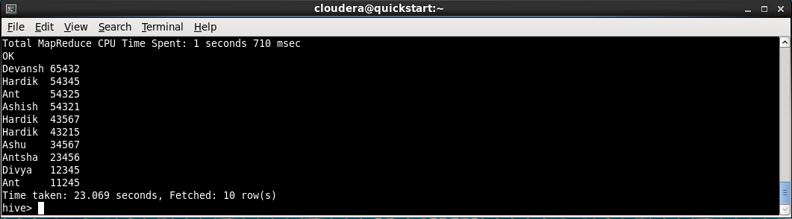
10. Display distinct date of births from ‘people’ table.
- SELECT DISTINCT dob FROM people;
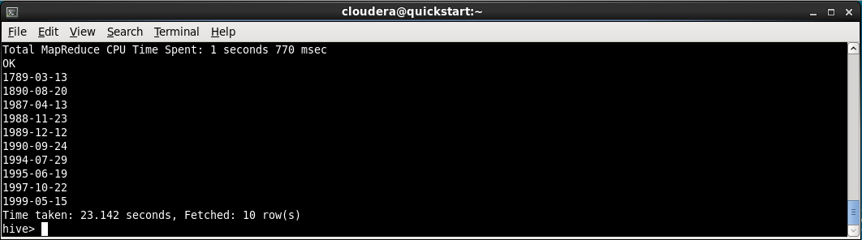
11. Display the person with maximum salary. :
- SELECT name, salary FROM people p1 WHERE p1.salary IN (SELECT MAX(salary) FROM people);
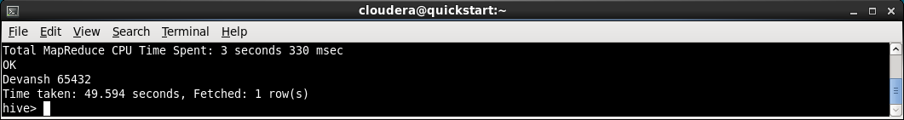
12. Find and display the average salary.
- SELECT AVG(salary) FROM people;
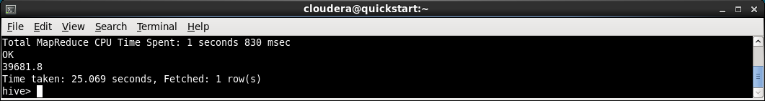
13. Display second highest salary.
- SELECT DISTINCT salary FROM (SELECT salary, DENSE_RANK() OVER(ORDER BY salary DESC) as rank FROM people) t WHERE rank = 2;
14. Create and partition a table named ‘emppartition’ on the mobile number column and load data into it.
- CREATE TABLE emppartition(emd_id INT, name STRING) PARTITIONED BY(m_no STRING) ROW FORMAT DELIMITED FIELDS TERMINATED BY ',';
- Set hive.exec.dynamic.partition.mode=nonstrict;
- INSERT INTO emppartition PARTITION(m_no) VALUES(1, ‘sam’, ‘1234567890’);
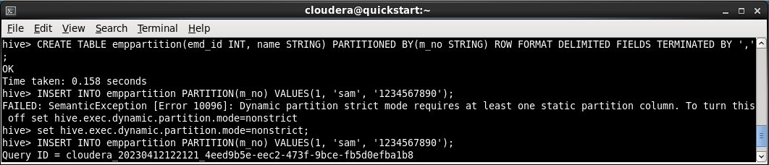
15. Create a table named ‘empbuckNoPartition’ with only bucketing on the mobile number column and load data into it.
- CREATE TABLE emp_buck_no_partition(emp_id INT, name STRING, m_no STRING) CLUSTERED BY (m_no) INTO 5 BUCKETS;
- INSERT INTO emp_buck_no_partition VALUES(1, 'xyz', '9283746251');
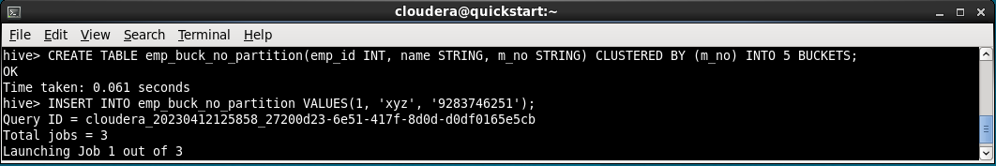

16. Create a table named ‘empbuckwithPartition’ with partitioning and bucketing on the mobile number column and load data into it.
- CREATE TABLE emp_buck_partition(emp_id INT, name STRING, m_no STRING) PARTITIONED BY(m_no2 STRING) CLUSTERED BY(m_no) INTO 5 BUCKETS;
- set hive.exec.dynamic.partition.mode=nonstrict;
- INSERT INTO emp_buck_partition PARTITION(m_no2) VALUES(1, 'asdf', '2345678901', '8945213743');
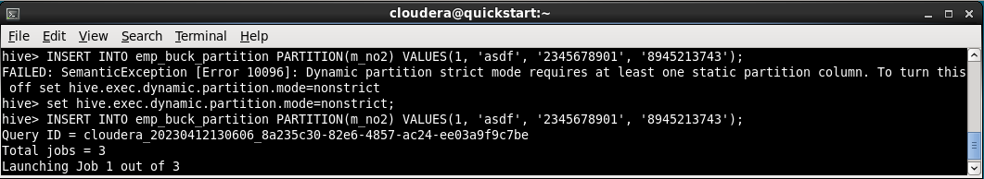

17. Display data from ‘emppartition’ , ‘empbuckNoPartition’ and ‘empbuckwithPartition’ tables.
- SELECT * FROM emppartition;
- SELECT * FROM emp_buck_no_partition;
- SELECT * FROM emp_buck_partition;
